

**HYPERSPECTRAL SUPER - RESOLUTION**

Report submitted for completion of training

(Satellite Meteorology and Oceanography Research and Training)

Programme of Space Applications Centre

**Submitted by**

**VITANSHI MOBANAPUTRA**

**(Registration No. 17MTPOS013)**

M.Tech. (Computer Science)

**Under the guidance of**

**Sri. Wosly Boy Lynbdoh**

SCI/ENG – SO

HRDD/AMBTDG/PSEA

Space Applications Centre, (ISRO) Ahmedabad

**Institution**

**Bharmsingh Desai University**

Nadiad– 387001

Gujarat

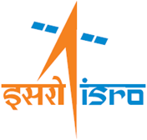

**SRTD-RTMG-MISA**

**S**pace **A**pplications **C**entre (ISRO)

Ahmedabad, Guajrat

03 July 2018 to 18 April 2019